|  |  |  |
| --- | --- | --- |
| UC Name | Search for Event by Venue | |
| Description | The Search for Event by Venue Use Case describes the process which will allow a CSA to search for events for a particular venue during a specified range of dates for a Patron. | |
| Actors | Customer Service Agent (CSA) | |
| Pre-Conditions | A CSA is available.  The TTS is operational.  The CSA is logged in to TTS. | |
| Post-Conditions | The patron’s query is answered. | |
| Triggers | A patron wants to know what events are scheduled for a particular Venue during a particular date range. | |
| Flow | | |
|  | Actor | System |
|  | Query for a specific venue |  |
|  |  | Search for a specific venue |
|  |  | Return venue results |
|  | Select a venue |  |
|  |  | Search for events for selected venue |
|  |  | Return event results for selected venue |
|  | Query for date range |  |
|  |  | Filter events for selected venue by date range |
|  |  | Return event results for selected venue and requested date range |

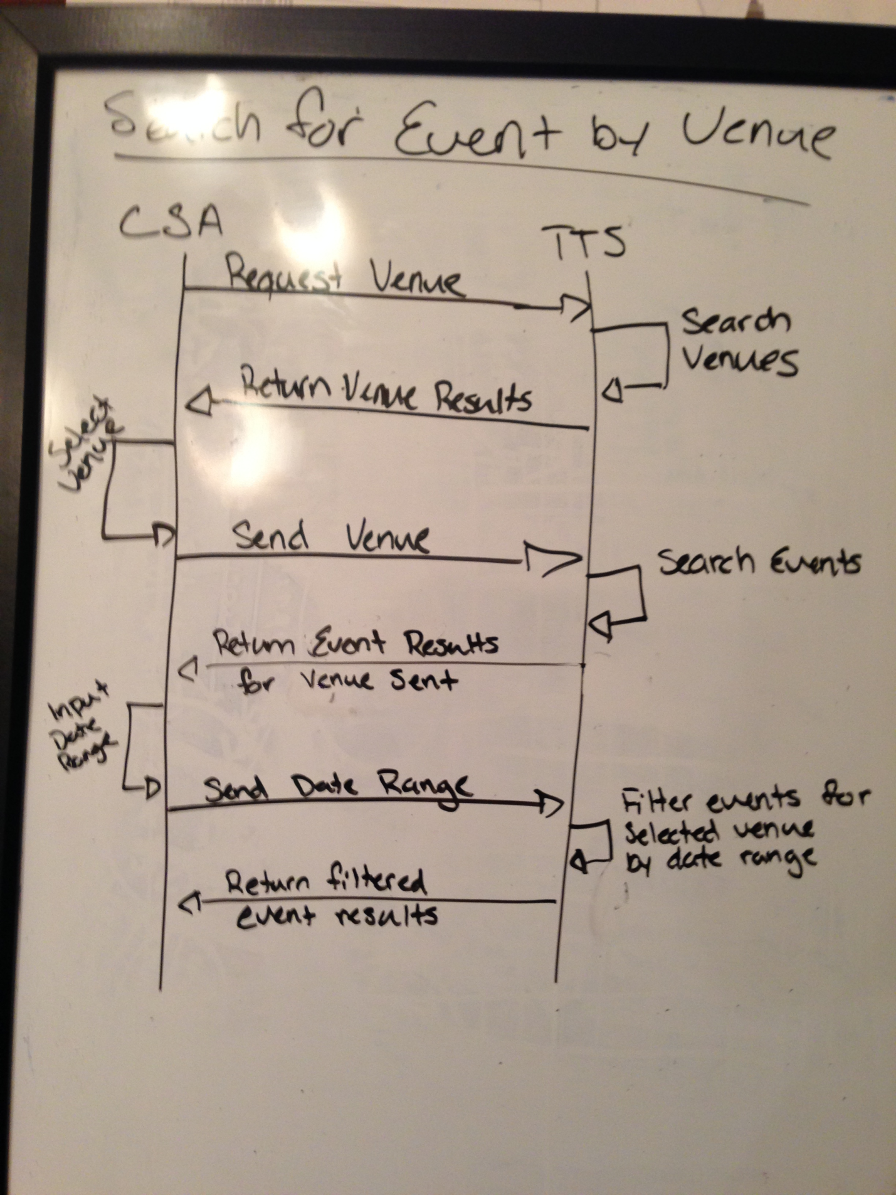

|  |  |
| --- | --- |
| TTS Requirement Number | Requirement Description |
|  | The TTS shall have the capability to search for venues. |
|  | The TTS shall have the capability to search for events by venue. |
|  | The TTS shall have the capability to filter events for a venue by a date range. |

|  |  |
| --- | --- |
| TTS Interface Requirement Number | Interface Requirement Description |
|  | The TTS shall have an interface to search for venues. |
|  | The TTS shall have an interface to display venue results. |
|  | The TTS shall have an interface to select a venue (??? “from venue results” ???) |
|  | The TTS shall have an interface to display event results by venue. |
|  | The TTS shall have an interface to input a date range used to filter event results by venue. |

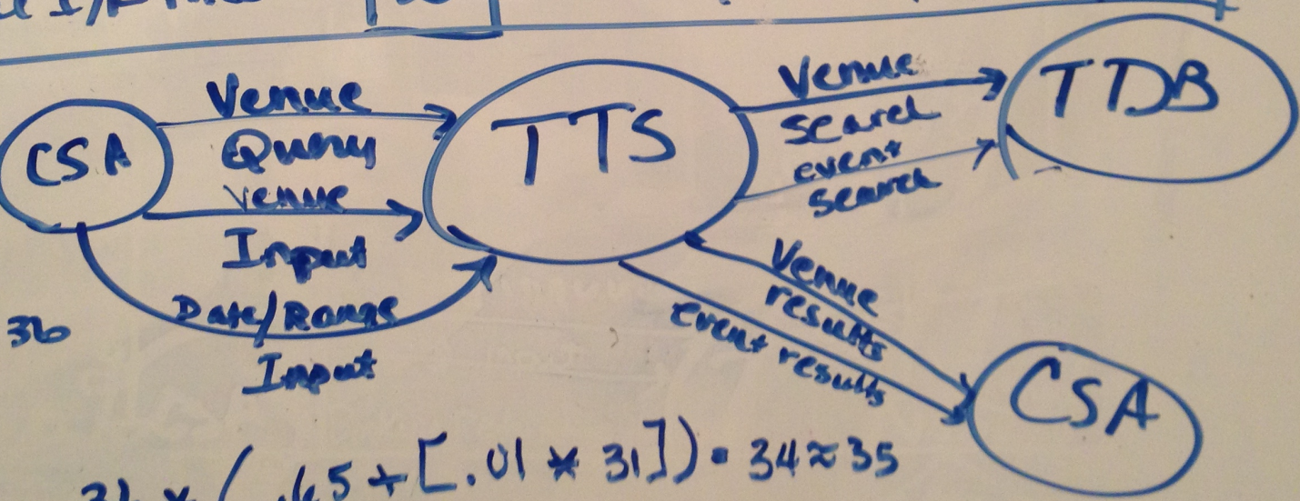

|  |  |
| --- | --- |
| Analysis question | Value |
| Does the system require reliable backup and recovery? | 0 |
| Are specialized data communications required to transfer information to or from the application? | 5 |
| Are there distributed processing functions? | 0 |
| Is performance critical? | 1 |
| Will the system run in an existing, heavily utilized operational environment? | 3 |
| Does the system required online data entry? | 5 |
| Does the online data entry require the input transition to be built over multiple screens or operations? | 3 |
| Are the internal logic files updated online? | 0 |
| Are the inputs, outputs, files, or inquiries complex? | 1 |
| Is the internal processing complete? | 1 |
| Is the code designed to be reusable? | 3 |
| Are conversion and installation included in the design? | 0 |
| Is the system designed for multiple installations in different organizations? | 5 |
| Is the application designed to facilitate change and ease of use by the user? | 4 |
| **Total** | 31 |

|  |  |  |  |  |  |
| --- | --- | --- | --- | --- | --- |
|  |  | Simple | Average | Complex | Count |
| External Inputs | 2 | 3 | 4 | 6 | 8 |
| External Outputs | 2 | 4 | 5 | 7 | 10 |
| External Inquiry | 1 | 3 | 4 | 6 | 4 |
| Internal Logic Files | 0 | 7 | 10 | 15 | 0 |
| External Interface Files | 2 | 5 | 7 | 10 | 14 |
|  | | | **Count Sub Total** | | 36 |
| **∑F** | | 31 |
| **FP Total** | | 35 |

|  |  |  |
| --- | --- | --- |
| UC Name | Patron Requested Refund Ticket | |
| Description | The Patron Requested Refund Ticket User Case describes the process which will allow a CSA to refund a purchased ticket for a patron, which will also unlock the booked seat associated with the purchased ticket for later reservations. | |
| Actors | Customer Service Agent (CSA) | |
| Pre-Conditions | A CSA is available.  The TTS is operational.  The CSA is logged in to TTS.  Patron has already purchased a ticket for a seat at an event. | |
| Assumptions | The third-party payment gateway returns a response to requests for refunds in real-time. | |
| Post-Conditions | The booked seat is unlocked. | |
| Triggers | A patron requests a refund for a particular seat at an event. | |
| Flow | | |
|  | Actor | System |
|  | Query for a specific event booking |  |
|  |  | Search for a specific event booking |
|  |  | Return booking results |
|  | Select booking to refund |  |
|  |  | Verify booking |
|  |  | Return seat to an unlocked state |
|  |  | Send request to third-party payment gateway for refund of purchase amount |
|  |  | Await third-party payment gateway response |
|  |  | Return refund confirmation results |

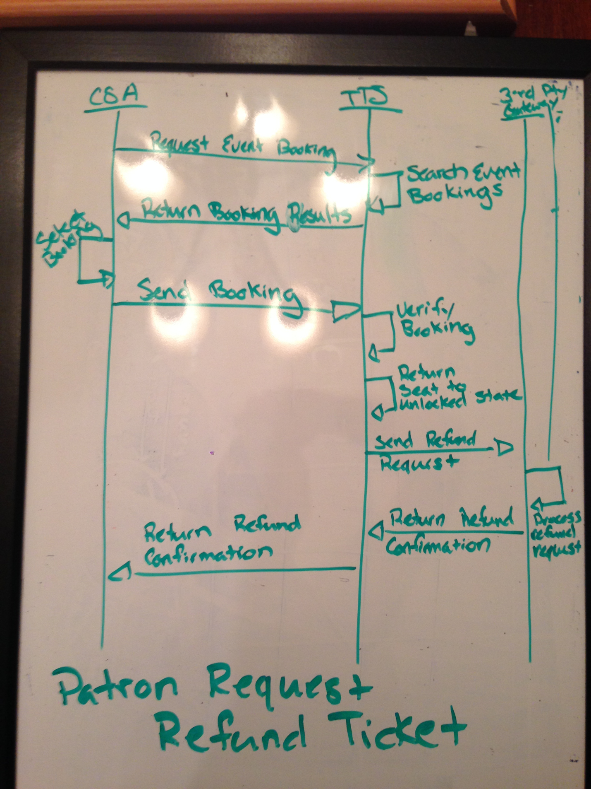

|  |  |
| --- | --- |
| TTS Requirement Number | Requirement Description |
|  | The TTS shall have the capability to search for event bookings |
|  | The TTS shall have the capability to verify an event booking can be refunded. |
|  | The TTS shall have the capability to unlock a seat. |
|  | The TTS shall have the capability to request a refund from the third-party payment gateway. |

|  |  |
| --- | --- |
| TTS Interface Requirement Number | Interface Requirement Description |
|  | The TTS shall have an interface to search for event bookings. |
|  | The TTS shall have an interface to display event bookings. |
|  | The TTS shall have an interface to select an event booking (?? “from event booking results” ???) |
|  | The TTS shall have an interface to display a refund confirmation. |

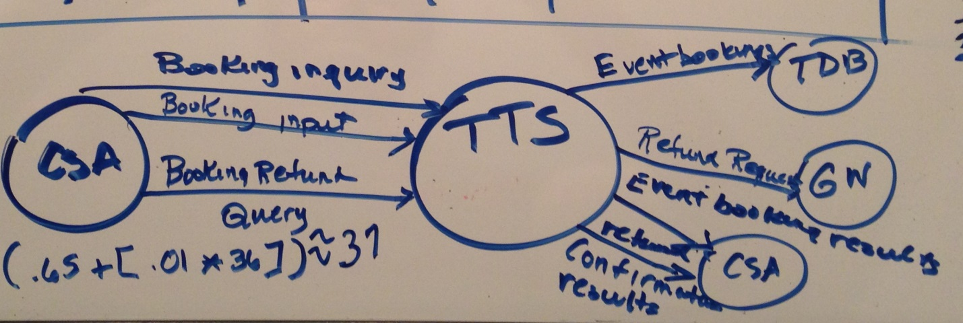

|  |  |
| --- | --- |
| Analysis question | Value |
| Does the system require reliable backup and recovery? | 5 |
| Are specialized data communications required to transfer information to or from the application? | 5 |
| Are there distributed processing functions? | 0 |
| Is performance critical? | 1 |
| Will the system run in an existing, heavily utilized operational environment? | 3 |
| Does the system required online data entry? | 5 |
| Does the online data entry require the input transition to be built over multiple screens or operations? | 3 |
| Are the internal logic files updated online? | 0 |
| Are the inputs, outputs, files, or inquiries complex? | 1 |
| Is the internal processing complete? | 1 |
| Is the code designed to be reusable? | 3 |
| Are conversion and installation included in the design? | 0 |
| Is the system designed for multiple installations in different organizations? | 5 |
| Is the application designed to facilitate change and ease of use by the user? | 4 |
| **Total** | 36 |

|  |  |  |  |  |  |
| --- | --- | --- | --- | --- | --- |
|  |  | Simple | Average | Complex | Count |
| External Inputs | 1 | 3 | 4 | 6 | 4 |
| External Outputs | 2 | 4 | 5 | 7 | 10 |
| External Inquiry | 3 | 3 | 4 | 6 | 8 |
| Internal Logic Files | 0 | 7 | 10 | 15 | 0 |
| External Interface Files | 2 | 5 | 7 | 10 | 14 |
|  | | | **Count Sub Total** | | 36 |
| **∑F** | | 36 |
| **FP Total** | | 37 |

|  |  |  |
| --- | --- | --- |
| UC Name | Refund All Tickets for an Event | |
| Description | The Refund All Tickets for an Event User Case describes the process which will allow a CSA to refund all purchased tickets for an event, which will also unlock all the booked seats associated with the event. | |
| Actors | Customer Service Agent (CSA) | |
| Pre-Conditions | A CSA is available.  The TTS is operational.  The CSA is logged in to TTS.  Patron has already purchased a ticket for a seat at an event. | |
| Assumptions | The third-party payment gateway returns a response to requests for refunds in real-time. | |
| Post-Conditions | All seats for the event are unlocked | |
| Triggers | CSA is directed (presumably by some higher authority) to refund all bookings for an event. | |
| Flow | | |
|  | Actor | System |
|  | Query for a specific event booking |  |
|  |  | Search for a specific event booking |
|  |  | Return booking results |
|  | Select all bookings for an event |  |
|  |  | Verify all bookings for the selected event |
|  |  | Return all seats for the selected event to an unlocked state |
|  |  | Send all requests to third-party payment gateway for refund of the purchase amount for each individual booking |
|  |  | Await third-party payment gateway response |
|  |  | Return all confirmation results |

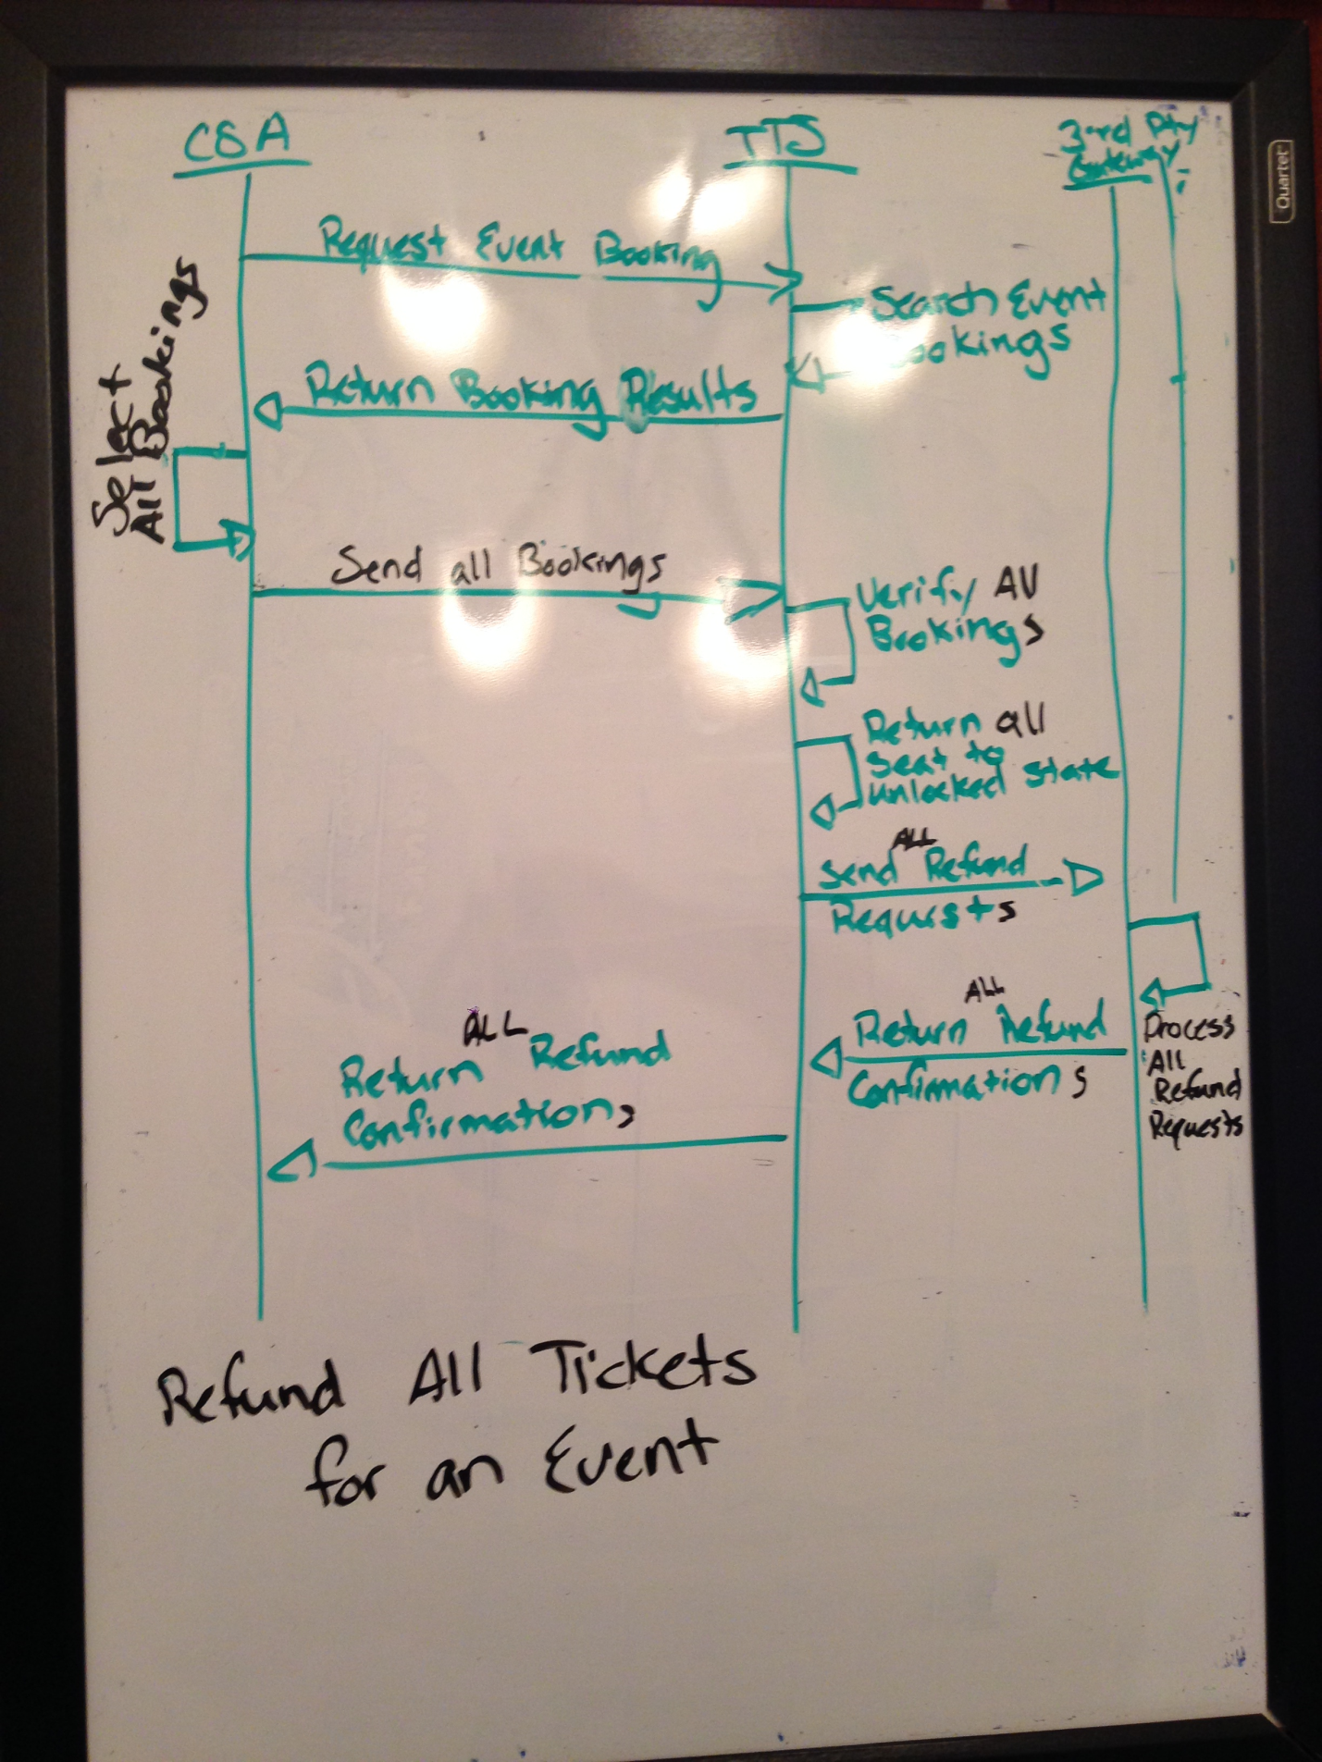

|  |  |
| --- | --- |
| TTS Interface Requirement Number | Interface Requirement Description |
|  | The TTS shall have an interface to select all event bookings for an event. |



|  |  |
| --- | --- |
| Analysis question | Value |
| Does the system require reliable backup and recovery? | 5 |
| Are specialized data communications required to transfer information to or from the application? | 5 |
| Are there distributed processing functions? | 0 |
| Is performance critical? | 1 |
| Will the system run in an existing, heavily utilized operational environment? | 3 |
| Does the system required online data entry? | 5 |
| Does the online data entry require the input transition to be built over multiple screens or operations? | 3 |
| Are the internal logic files updated online? | 0 |
| Are the inputs, outputs, files, or inquiries complex? | 1 |
| Is the internal processing complete? | 1 |
| Is the code designed to be reusable? | 3 |
| Are conversion and installation included in the design? | 0 |
| Is the system designed for multiple installations in different organizations? | 5 |
| Is the application designed to facilitate change and ease of use by the user? | 4 |
| **Total** | 36 |

|  |  |  |  |  |  |
| --- | --- | --- | --- | --- | --- |
|  |  | Simple | Average | Complex | Count |
| External Inputs | 1 | 3 | 4 | 6 | 4 |
| External Outputs | 2 | 4 | 5 | 7 | 10 |
| External Inquiry | 3 | 3 | 4 | 6 | 8 |
| Internal Logic Files | 0 | 7 | 10 | 15 | 0 |
| External Interface Files | 2 | 5 | 7 | 10 | 14 |
|  | | | **Count Sub Total** | | 36 |
| **∑F** | | 36 |
| **FP Total** | | 37 |

Glossary

|  |  |
| --- | --- |
| Unlocked Seat | A particular seat at an event which has not been purchased by a patron and is not in the process of being reserved. |
| Locked Seat | A particular seat at an event which is in the process of being reserved but to which the system has not yet been able to associate a patron. |
| Reserved Seat | A particular seat at an event which is associated with a patron but has not yet been paid for. |
| Booked Seat | A particular seat at an event which is associated with a patron and has been paid for. |